Assignment No.:

Client Server Architecture wrt CORBA

Overview of CORBA
The Common Object Request Broker Architecture (CORBA) is an emerging open distributed object computing infrastructure being standardized by the Object Management Group (OMG). CORBA automates many common network programming tasks such as object registration, location, and activation; request demultiplexing; framing and error-handling; parameter marshalling and demarshalling; and operation dispatching.

CORBA provides some of the following features
- Static and Dynamic Method Invocations: CORBA ORB lets you either statically define your method invocations at compile time or it lets you dynamically discover them at run time (referred to as DII)
- High-Level Language Bindings: CORBA separates interface from implementation and provides language -neutral types that make it possible to call objects across language and operating system boundaries.
- Built-in Security and Transactions: The ORB includes context information in its messages to handle security and transactions across machine and ORB boundaries.
- Coexistence with existing systems: Using CORBA IDL, it possible to make existing code look like an object on the ORB, even if it's implemented in stored procedures, COBOL or C++. Basically the code can be written in any language and then can be connected through ORB.

The following figure illustrates the primary components in the OMG Reference Model architecture. Descriptions of these components are available further below.

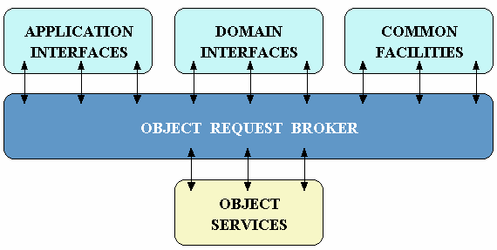
Figure 1. OMG Reference Model Architecture
- Object Services -- These are domain-independent interfaces that are used by many distributed object programs. For example, a service providing for the discovery of other available services is almost always necessary regardless of the application domain. Two examples of Object Services that fulfill this role are:
  - The Naming Service -- which allows clients to find objects based on names;
  - The Trading Service -- which allows clients to find objects based on their properties.
There are also Object Service specifications for lifecycle management, security, transactions, and event notification, as well as many others
- Common Facilities -- Like Object Service interfaces, these interfaces are also horizontally-oriented, but unlike Object Services they are oriented towards end-user applications. An example of such a facility is the Distributed Document Component Facility (DDCF), a compound document Common Facility based on OpenDoc. DDCF allows for the presentation and interchange of objects based on a document model, for example, facilitating the linking of a spreadsheet object into a report document.
- Domain Interfaces -- These interfaces fill roles similar to Object Services and Common Facilities but are oriented towards specific application domains. For example, one of the first OMG RFPs issued for Domain Interfaces is for Product Data Management (PDM) Enablers for the manufacturing domain. Other OMG RFPs will soon be issued in the telecommunications, medical, and financial domains.
- Application Interfaces - These are interfaces developed specifically for a given application. Because they are application-specific, and because the OMG does not develop applications (only specifications), these interfaces are not standardized. However, if over time it appears that certain broadly useful services emerge out of a particular application domain, they might become candidates for future OMG standardization.

CORBA ORB Architecture
The following figure illustrates the primary components in the CORBA ORB architecture. Descriptions of these components are available below the figure.

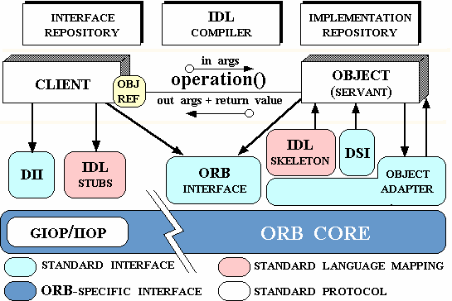
Figure 2. CORBA ORB Architecture
- Object -- This is a CORBA programming entity that consists of an identity, an interface, and an implementation, which is known as a Servant.

- Servant -- This is an implementation programming language entity that defines the operations that support a CORBA IDL interface. Servants can be written in a variety of languages, including C, C++, Java, Smalltalk, and Ada.
- Client -- This is the program entity that invokes an operation on an object implementation. Accessing the services of a remote object should be transparent to the caller. Ideally, it should be as simple as calling a method on an object, i.e., obj->op(args). The remaining components in Figure 2 help to support this level of transparency.

- Object Request Broker (ORB) -- The ORB provides a mechanism for transparently communicating client requests to target object implementations. The ORB simplifies distributed programming by decoupling the client from the details of the method invocations. This makes client requests appear to be local procedure calls. When a client invokes an operation, the ORB is responsible for finding the object implementation, transparently activating it if necessary, delivering the request to the object, and returning any response to the caller.

- ORB Interface -- An ORB is a logical entity that may be implemented in various ways (such as one or more processes or a set of libraries). To decouple applications from implementation details, the CORBA specification defines an abstract interface for an ORB. This interface provides various helper functions such as converting object references to strings and vice versa, and creating argument lists for requests made through the dynamic invocation interface described below.

- CORBA IDL stubs and skeletons -- CORBA IDL stubs and skeletons serve as the ``glue'' between the client and server applications, respectively, and the ORB. The transformation between CORBA IDL definitions and the target programming language is automated by a CORBA IDL compiler. The use of a compiler reduces the potential for inconsistencies between client stubs and server skeletons and increases opportunities for automated compiler optimizations.

- Dynamic Invocation Interface (DII) -- This interface allows a client to directly access the underlying request mechanisms provided by an ORB. Applications use the DII to dynamically issue requests to objects without requiring IDL interface-specific stubs to be linked in. Unlike IDL stubs (which only allow RPC-style requests), the DII also allows clients to make non-blocking deferred synchronous (separate send and receive operations) and oneway (send-only) calls.

- Dynamic Skeleton Interface (DSI) -- This is the server side's analogue to the client side's DII. The DSI allows an ORB to deliver requests to an object implementation that does not have compile-time knowledge of the type of the object it is implementing. The client making the request has no idea whether the implementation is using the type-specific IDL skeletons or is using the dynamic skeletons.

- Object Adapter -- This assists the ORB with delivering requests to the object and with activating the object. More importantly, an object adapter associates object implementations with the ORB. Object adapters can be specialized to provide support for certain object implementation styles (such as OODB object adapters for persistence and library object adapters for non-remote objects).
Advantages of CORBA
The advantages of CORBA are discussed as follows:
1.Object Location Transparency: The client does not need to know where an object is physically located. An object can either be linked into the client, run in a different process on the same machine, or run in a server on the other side of the planet. A request invocation looks the same regardless, and the location of an object can change over time without, breaking applications.
2. Server Transparency: The client is, as far as the programming model is concerned, ignorant of the existence of servers. The client does not know (and cannot find out) which server hosts a particular object, and does not care whether the server is running at the time the client invokes a request.
3. Language Transparency: Client and server can be written in different languages. This fact encapsulates the whole point of CORBA; that is, the strengths of different languages can be utilized to develop different aspects of a system, which can interoperate through IDL. A server can be implemented in a different language without clients being aware of this.
4. Implementation Transparency: The client is unaware of how objects are implemented. A server can use ordinary flat files as its persistent store today and use an OO database tomorrow, without clients ever noticing a difference (other than performance).
5. Architecture Transparency: The idiosyncrasies of CPU architectures are hidden from both clients and servers. A little-endian client can communicate with a big-endian server with different alignment restrictions.
6.Operating System Transparency: Client and server are unaffected by each other's operating system. In addition, source code does not change if you need to port the source from one operating system to another.
7. Protocol Transparency: Clients and servers do not care about the data link and transport layer. They can communicate via token ring, Ethernet, wireless links, ATM (Asynchronous Transfer Mode), or any number of other networking technologies.

Server Side
Implementing the server side is not much more difficult than the client. The server, instead of acquiring a reference to a CORBA object, needs to activate an object and create a reference to be given to the client.
Servants, which are the actual implementations of CORBA objects, need to be registered with the ORB so that requests can be delivered to them. They are not directly registered with the ORB, but instead with an Object Adaptor. The best and most supported adaptor at the present is the Portable Object Adaptor, or POA, although the older Basic Object Adaptor is still commonly found.
The server needs to create a servant object that will actually do the work. This Java object should be subclasses from the provided POA class, HelloPOA in our case. Doing this provides the tools that the ORB and POA need to activate the object and handle requests. The class declaration might look like:
public class HelloImpl extends HelloPOA { ... }
The class also needs to have implemented the methods from the idl. The exact syntax of the call can be copied from the Operations class. In our case it is
public String say_hi(String my_name) throws BadMood
The server must create an instance of the class and then get a Corba proxy for the object. The code to so this is:
HelloImpl myHello = new HelloImpl();
Hello corbaHello = myHello._this(orb);
The second line does the actual registration on the default POA and returns the Corba proxy object. There are many ways and options for registering an object with a POA, which won't be covered here.
A server must get activate the POA that it registered the servant with. To do this it must get the POA from the ORB and can do this via the ORB's resolve_initial_references method. For example,
org.omg.PortableServer.POA root = null;
root = org.omg.PortableServer.POAHelper.narrow(
orb.resolve_initial_references("RootPOA"));
Once it has the POA, it needs to call the activate() method on the POA's manager. For example: org.omg.PortableServer.POAManager manager =
root.the_POAManager();
manager.activate();
The last thing that needs to be done to make a server active is to tell the ORB to start up and receive requests. This is done with the run() method on the ORB. This method does not return unless there is an error, and so the server will continue to process requests until killed.
orb.run();

Client Side
Hello.java is the client side proxy. It is a Java interface that extends Hello Operations and so the methods of the Corba interface are there. When the client make a call on this object, it feelslocal because the call is local, so far as the client is concerned. What actually happens is that the Hello Java object behind this interface is actually an _HelloStub object that works with the ORB to deliver the request to the server.
Writing a client that can use this interface is actually fairly straightforward. There are two main steps. First you have to get a reference to the Hello object somehow. The easiest way would be for it to be returned by a previous Corba call. This is the way that most references are gotten, but this doesn't help you to bootstrap the first reference. For getting the first reference, there are several ways that CORBA references can be turned into strings. The first is an IOR, which is a big string of numbers that contains all the information needed for the ORB to create a valid proxy and to find the server, including the internet address, port number, and an object id. There are other ways for ORBs to obtain initial references, but we won’t go into them now.
Because a CORBA reference can be turned into a string, it is fairly straightforward to have the server write out its IOR to a text file and then have the client read it in. The code to do this might look something like
String ref = null;
String refFile = "Hello.ref";
FileInputStream file = new FileInputStream(refFile);
BufferedReader in =
new BufferedReader(new InputStreamReader(file));
ref = in.readLine();
file.close();
Once the IOR is read in, it needs to be converted to a Corba object. There is a method, string_to_object, that the orb supplies that does this. The code might look like this, presuming the ORB has already been initialized.
org.omg.CORBA.Object obj = orb.string_to_object(ref);
Now what we have is a Corba object, and so we need to narrow it to a Hello object. This is accomplished with the narrow method that is supplied in the Helper class.
Hello hello = HelloHelper.narrow(obj);
Now the hello object is ready to run, and we can make calls on it just as if it were a plain old Java object.
String message = hello.say_hi("Fred");

